NewsletterPro Administrative User’s Guide

1. How do I Login into the Newsletter Pro marketing system?
2. How do I create a new newsletter?
3. How do I create the section headers within the newsletter?
4. Other functionality
5. How do I create / copy a graphic that I want to insert into the newsletter?
6. How do I insert a graphic into the newsletter?
7. How do I delete a post / newsletter?
8. How do I save the newsletter part way through to then see how it is going to look with all the cosmetic HTML/graphics formatting?
9. How do I edit and delete newsletters?
10. How do I use the search feature?
- How do I view, add and delete subscribers?
- How to add PDF, Publisher, etc. docs to NewsletterPro Online?
- I’ve already published a newsletter. How can I create a newsletter just like it, or very similar?
- How do I create a table within the document?
- How do I send a regular email to all the subscribers?
- How do I send a test copy of the newletter to myself (admin) or the Test group?

1. How do I Login into the Newsletter Pro marketing system?

When you are going to begin using the Newsletter Pro marketing system, you will need to enter your username and password (see Figure 1). Also, you can click on the box which states - ‘Remember me’ to have it remember your login information. After you have entered the correct username/password click the Login button.

Note: If you lose your password, click once on Lose your password and you will be taken to a screen where you can enter your username and the system will create a new password for you. It will send the new password to the email address you used to create your account. Once you enter your username, click Retrieve Password and visit your email to retrieve the password and login. But if you change the Admin password please let the other Admin account users know.

Figure 1: NewsletterPro login screen

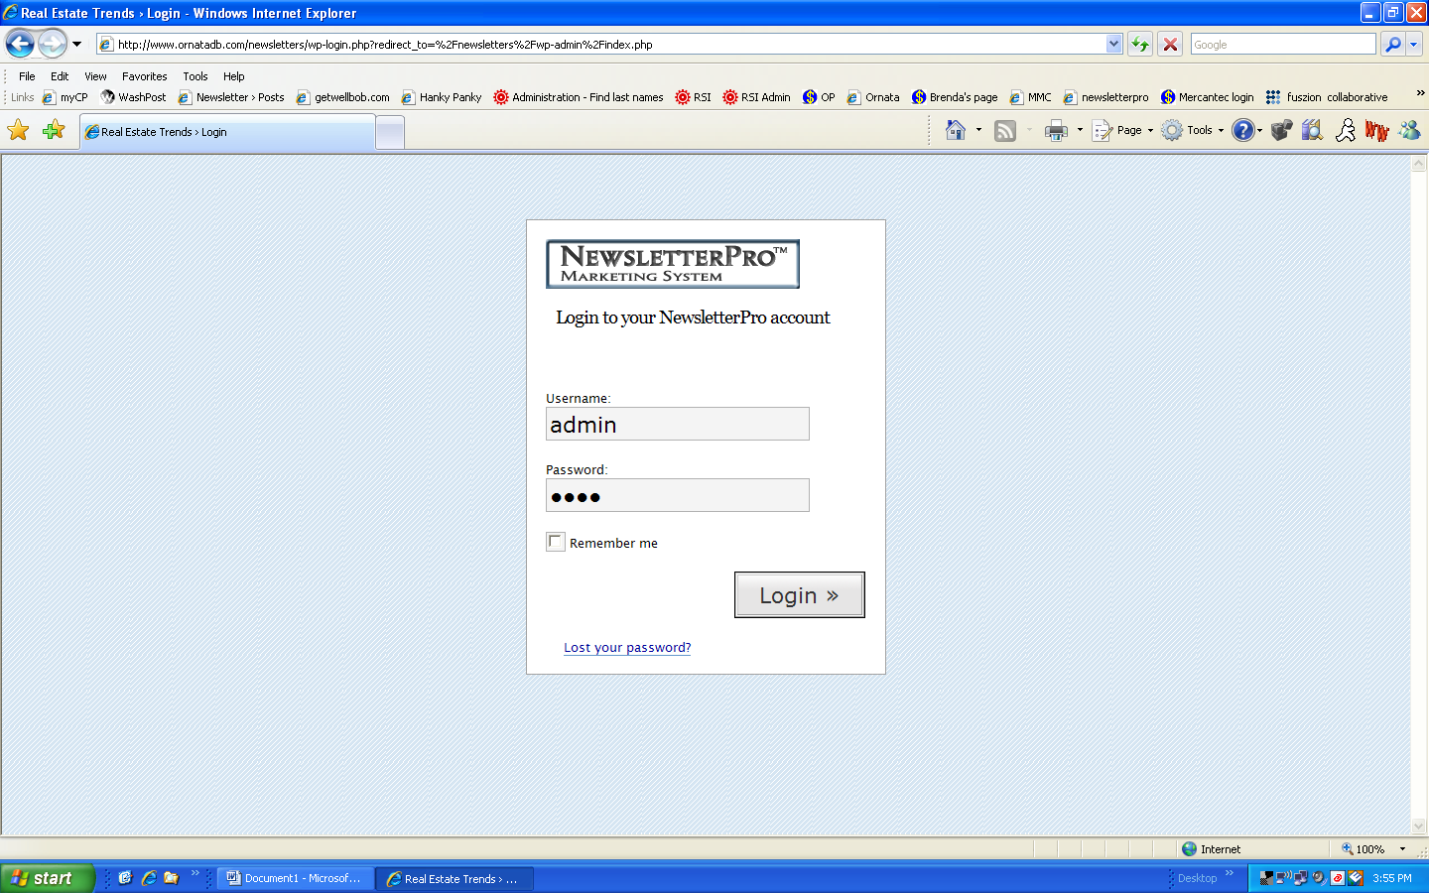

2. How do I create a new newsletter?

- Click the Write Tab, which will take you to the Write Newsletter section.
- Write Post defines where you will enter your title of the new newsletter. Here
you can enter new title, and then in the “Post” section create the newsletter. You can edit your content like you do with Microsoft Word editor. You can do special formatting (bold, italics, line items, etc) with the format choices at the top.
- To create section headers see Section 3 below.
- Periodically click “Save and Continue editing” to save your work and keep working on the document.
- Click “Save” if you want to save your work and leave the Edit mode. Then you can come back in later to edit again.
- Click “Publish” when you are ready to publish the newsletter out to all the subscribers. Once a newsletter has been published it will [obviously] no longer be listed in the drafts page (”Write” section), and it will be instead in the published section (“Manage” section).
- A file will be saved as DRAFT until you actually publish it. There can be as many current Drafts as you want.

3. How do I create the section headers within the newsletter?

- To create section headers, that now include the specific stock photos for each section - Click on the header 1, 2 or 3 buttons and the following pop up screen will appear.

Figure 2: How to add Headers screenshot

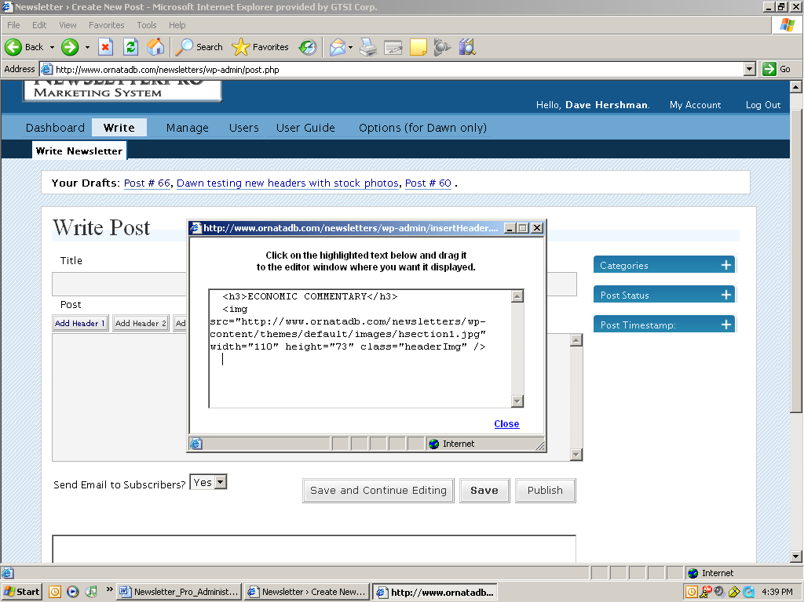

- In the screen will appear html text that you can click on the highlighted text below and drag it to the editor window where you want it displayed. This will create the section header and product code for that and the stock photo for that section. Once you have dragged and dropped the code you can change the section header that is between the “<h3>” HTML tags. You can follow the same process for each of the 3 headers.
One tiny thing to note for this...once you drop the header code into the editor, you have to start your paragraph copy on the same line (probably best to separate the code from the text with a space). If you drop the code and hit "enter" to a new line, the wysiwyg will put the text into a new paragraph and place it below the image...it's a real easy thing to swing if you get in the habit of saving and looking at the preview window before publishing. (which you should do anyway)

4. Other functionality

Post Status
To check on the status of the newsletter you can click on three options here.
- Published
- Draft
- Private

Post Timestamp
In this section you can review or edit when you posted your newsletter by month, day, year, and time including seconds.

After you completed your edits with the content you have placed on the copy, you have the following options:

5. How do I create / copy a graphic that I want to insert into the newsletter?

HTML pages need to reside on a server in cyberspace somewhere. If you have images within an HTML page they have to be separate image files. The HTML editor we gave you lets you pull them all together in one newsletter. So if you want to "borrow" a graphic from somewhere, you can copy it into Paint or whatever you are familiar with, then save it as a .gif or .jpg. This will make it its own separate file. Then you upload that single image file to the NewsletterPro server (via the instructions in #6 below) so that it resides in cyberspace. Then you can include that image in as many newsletters as you want.

6. How do I insert a graphic into the newsletter?
In the section labeled “Upload/ Browse All” you can browse for a certain file on your computer and name it a certain title and provide a description of what the file is. Once you have uploaded the file you can upload it to any newsletter.

To load the image in the newsletter, highlight the image with your mouse. Click on either “using thumbnail” or “using original” to decide which size of the image to use. Then click “Send to Newsletter” to insert it into the newsletter wherever the mouse was within the newsletter body.

7. How do I delete a post / newsletter?
You also have the option to delete certain posts. If you don’t want to post the above section you can hit Delete this post.

8. How do I save the newsletter part way through to then see how it is going to look with all the cosmetic HTML/graphics formatting?

When you are adding information to the newsletter, you can save your information and continue to edit. To do this, under the Write Post section, click “Save and Continue to Editing.”

Once you have clicked “Save and Continue to Editing”, you can page down on the edit screen to preview the newsletter, formatted in HTML. You can also review your newsletter by hitting the Preview button that appears on the top of the page, which will page down to the Preview section. In the Preview section you can click “edit”, which will take you back up to the edit section (or simply click page up and page down).

Figure 3: Write Newsletter screen

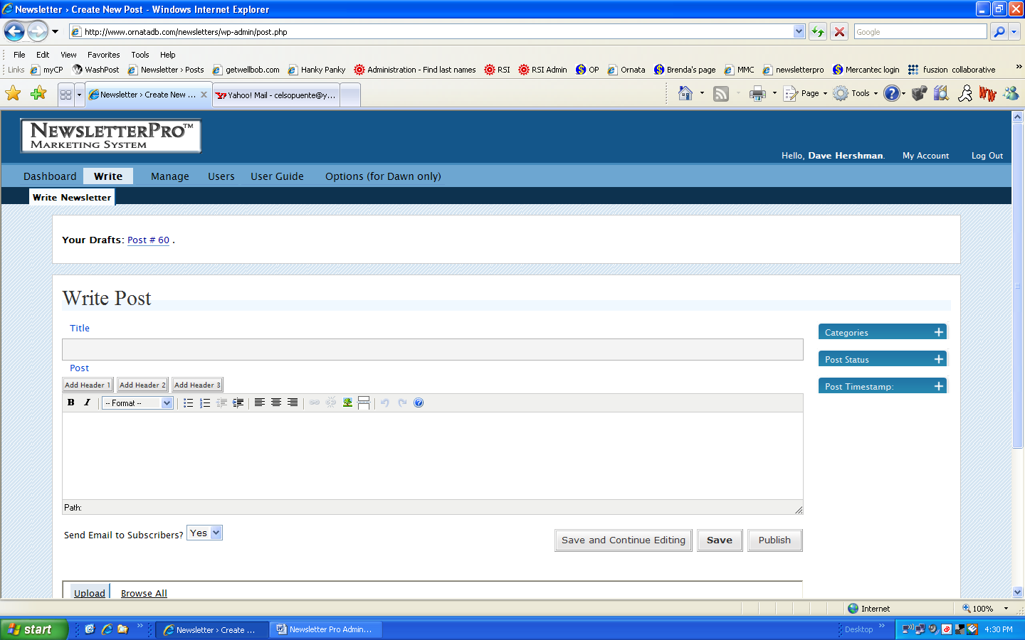

9. How do I edit and delete newsletters?

Visit manage tab located in the upper top hand corner of the screen.

In this section, you can manage your newsletter by editing or deleting past, current or future copies. Simply click edit or delete under the newsletters that you want to retain or delete.

Newsletters are categorized in the following format for easy review.

- ID
- When
- Title
- Categories
- Author
- URL
- Edit/Delete- (Note: This is the area where you either keep or delete your stories after you have searched and reviewed them.)

Figure 4: Manage Newsletter screen shot

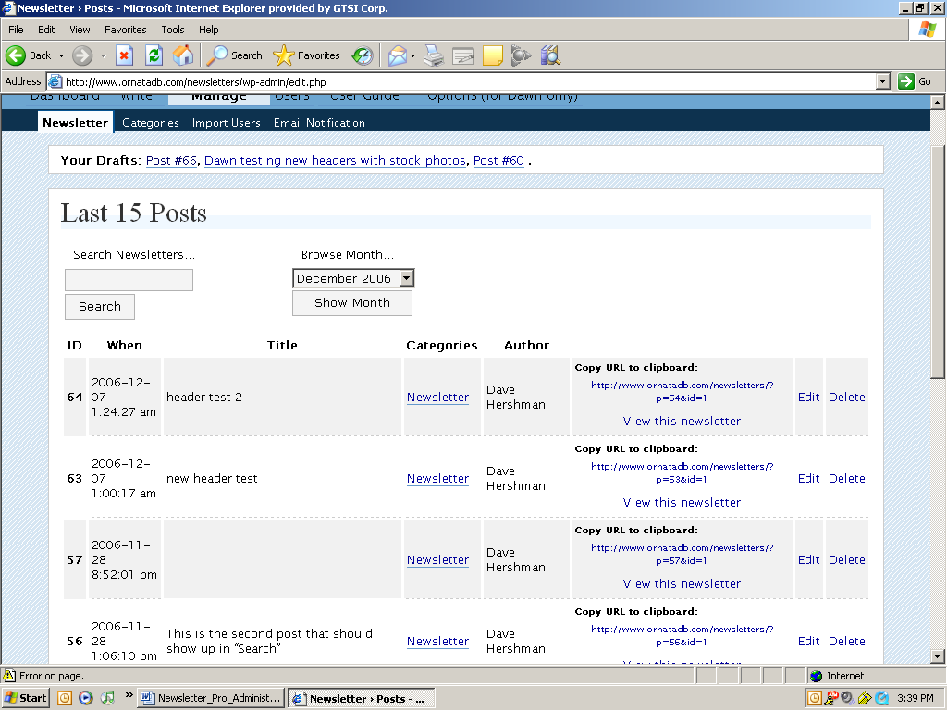

10. How do I use the search feature?
You can search for the newsletter by keyword or by searching by months. All you have to do is enter the keyword in the box named, Search newsletters or by clicking on the drop down box that show past months

11. How do I view, add and delete users?
In this section, you can view, add, delete, or modify users.

User List by Role- Administrator

Figure 5: Screenshot of User List by Role-Administrator and Subscriber

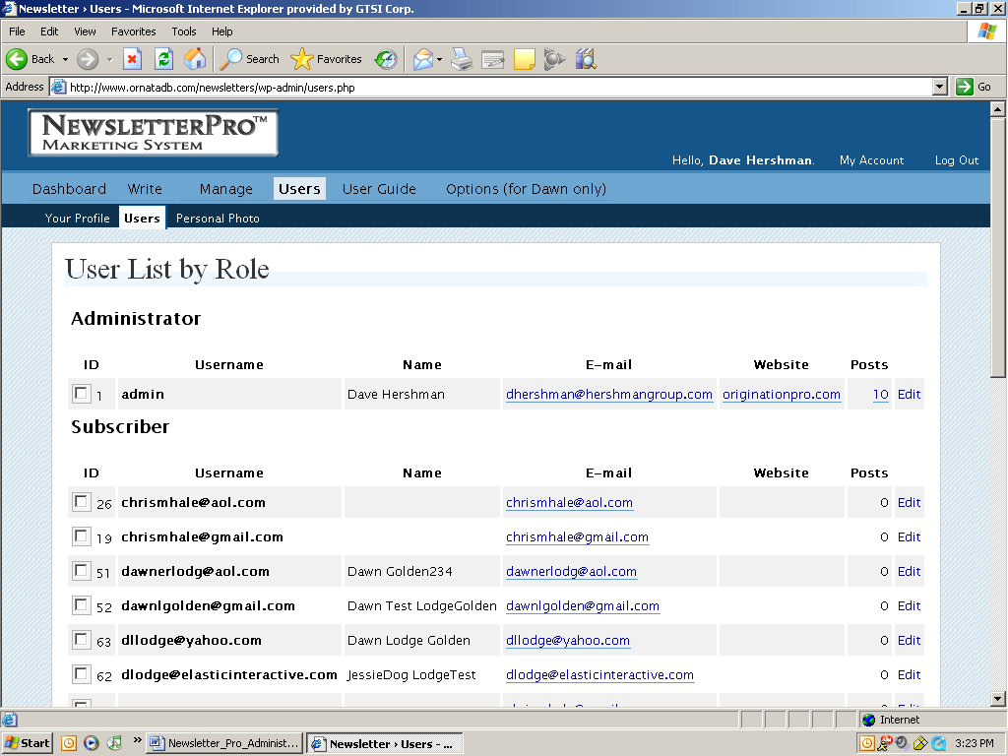

Subscriber
In this section you can see and edit who currently subscribes to your newsletter. Each of the following sections are divided by
- Id
- Username
- Name
- Email
- Website
- Posts

Update users
Delete checked users and set the role of checked uses to administrator or subscriber.

Add new users
In this section AT THE BOTTOM OF THE PAGE you can add new users. You can manually create users here by:
- Username – THIS IS CASE SENSITIVE, and might or might not be the email address... but THIS is what you have the user use to log in.
- First Name
- Last Name
- E-mail
- Website
- Password (which you enter twice) – THIS IS CASE SENSITIVE.

Once you have entered all information, click “add user”, and you are done – see screenshot below of the “Add New User” fields on the “Users” Admin page:
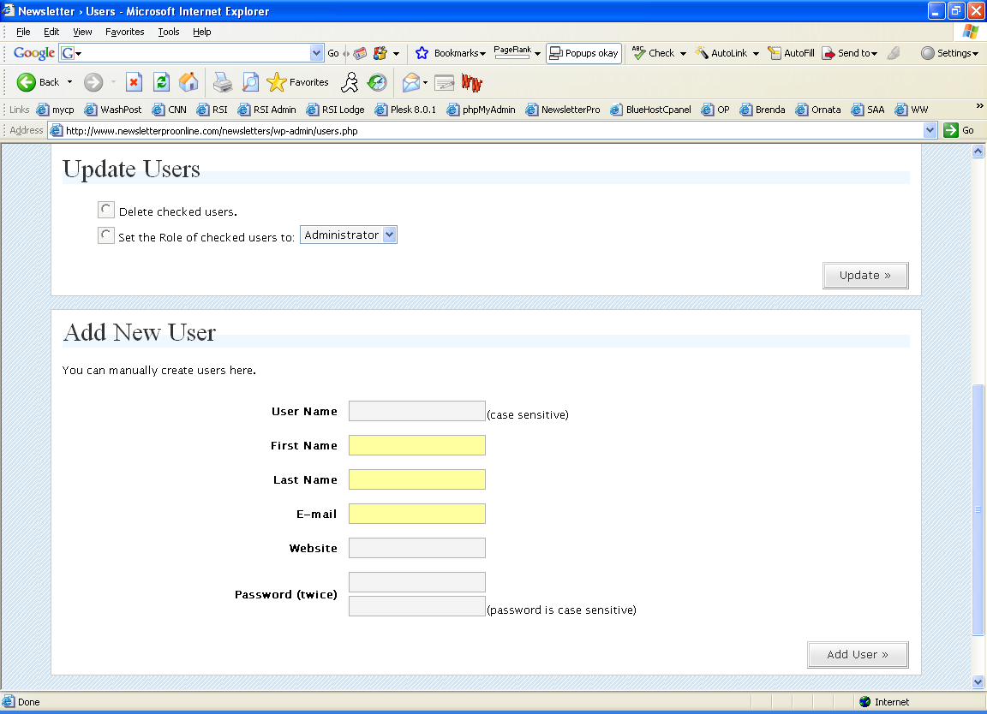

- How do I add PDF, Publisher, etc. docs to NewsletterPro Online?

  - Go to the [new] location login at: http://www.newsletterproonline.com/newsletters/wp-login.php

  - Login as Admin: userid: admin, password: hersh1

  - You'll see the new section on the home page ("dashboard"), it is called "Sales Update™, The Real Estate Trends™, The Real Estate Update™, and The Real Estate Page™” currently.

  - To add / edit / delete newsletters, articles, PDFs, etc in the new "Monthlies" section, click on "Manage". Then in the "Manage" page, click on "Pages" on the submenu. DO NOT "CREATE A NEW PAGE" ... simply work on the existing one that is already there -- Sales Update™, The Real Estate Trends™, The Real Estate Update™, and The Real Estate Page™ ".
  - Click on "Edit" (out to the far right) to EDIT the articles that are listed on that page. DO NOT CLICK "DELETE" or you will delete that entire page.

  - When in edit mode you will see the familiar edit section. This has links to the PDFs, Word docs, etc that you have uploaded. You can name them any name you choose and put them in any order you want. You can use regular text among the document links.

  - To upload a new PDF, publisher doc, etc: In the section below the "Edit" section, you will see PDFs and other docs that have been uploaded. You can upload as many as you like, and then only create live links in the "edit" section of the live page when you are ready. Click on "Upload" to upload a new doc. In the Upload window, click "browse" to find the file on your computer that you want to upload, give it whatever name you want (which will show in the listing of the available documents), and click “upload.”

  - When you want to add an uploaded document to the live page, simply put your mouse over the document in the document section, and drag and drop it to wherever you want it to go on the live page in the "Edit" section. You can change the title/name if you want after you have dragged and dropped it. (See Bullet #7) Click "Save" to go back to the live page to see your results (or you can also see the page in progress at the bottom of the page; it is only updated after you click "save and continue editing" or "save". "Save" saves the page and takes you out of edit mode; "Save and continue editing" does exactly what it says.

  - How do I name a file that I have uploaded?

- When you upload the file you can call it anything you want -- I'd do it something similar to "January9RealEstateReport.pdf".

- Use your mouse to move it into the editing part. It will automatically make it the same as the file name, but leave off the file extension. In this case the link would be called "January9RealEstateReport".

- Use the regular edit feature to retype the name of the link.

  - How do I get the PDF or other file to open in a new browser window?
- Put your mouse over the file link that you want to open in a new browser window and left click to select it (in any spot) – See Figure 6
- Click the “chain” icon in the menu to add or edit a link. Since this link to the file already exists, it will automatically EDIT it
- In the “target”, select “Open link in a new window” – See Figure 7
- Hit “Update” to save your action
- On the main file listing page, select “Save and continue Editing”, or “Save” to save everything on this page
Figure 6: Setting a link to open in a new browser window – Step 1
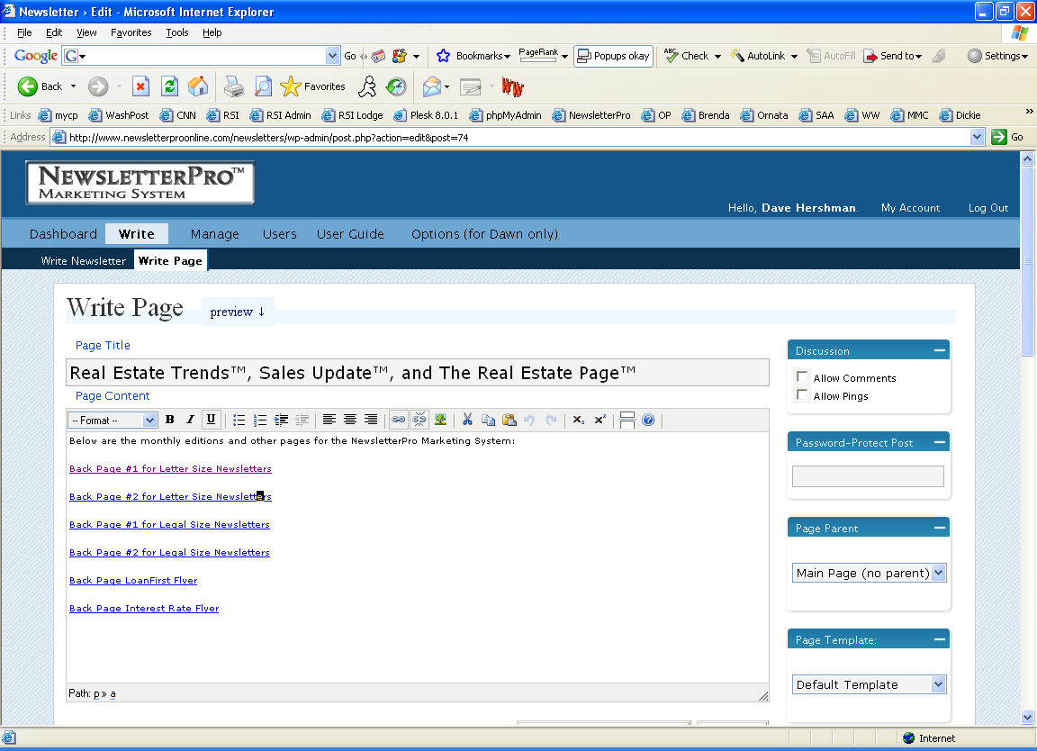

Figure 7: Setting a link to open in a new browser window – Step 2
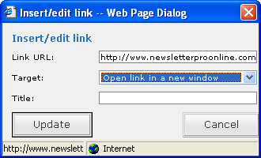

13. I’ve already published a newsletter and it has gone out to all the subscribers. How can I create a newsletter just like it, or very similar?
Once a newsletter is published... well, it is published. That is for user-safety so that you don’t accidentally keep sending a newsletter to your subscribers over and over. So in order to send a copy of it, or a near-copy of it, you’ll need to create a NEW newsletter, of course, and then copy and paste from the already-published one:
- In the top navigation, click on “Manage”, where you’ll find all the previously published copies of the newsletter. Find the one you want to make a copy of.
- Click “edit” – in the far right hand side of that newsletter line item (see Figure 8 below)
- Now you’ll get the familiar “Write Newsletter” (i.e., edit) page ... with one big exception – the Publish button is gone. This is because you have already sent this newsletter, and you certainly wouldn’t want to confuse your subscribers and send it again to the entire subscriber distro list.
- Use your mouse to highlight as much of the newsletter content that you want in the edit window, and hit “Ctrl-C” (just like in Word, Excel, etc) to copy that text to your Windows clipboard. If you know you want to copy ALL of the text then hit “Ctrl-A” to select ALL the text in that window, then “Ctrl-C” to copy that text to the clipboard.
- No need to save your work or anything....
- Now click “Write Newsletter” to bring up a blank screen to start a new newsletter. Hit “Ctrl-V” to paste the clipboard contents into the edit window. Now edit as needed.

Figure 8: Selecting a newsletter that has already been published in order to copy some or all of the content (or edit it and resave it for the archives)

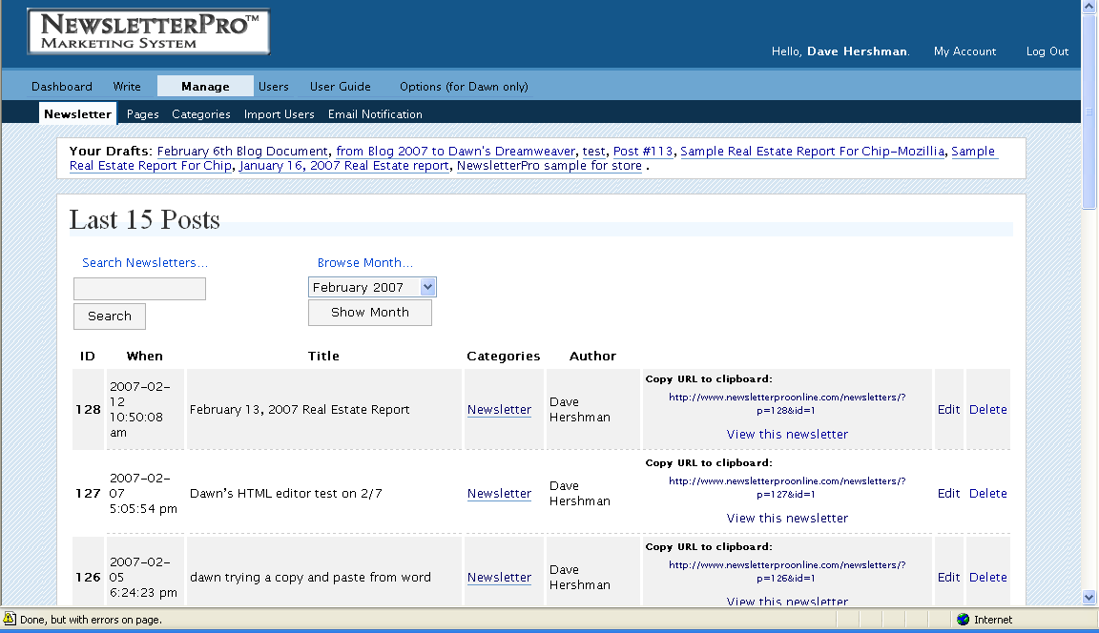

14. How do I create a table?
Put your mouse wherever you want a table in the newsletter. Click the “table” button. The following table creation screen pops up:
Figure 9: Table creation options popup window:

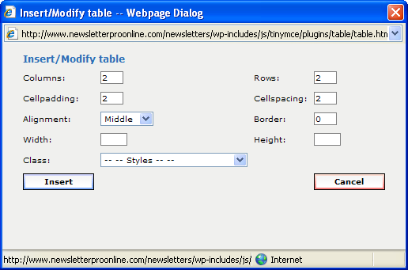

Type in how many columns and rows you want in the table. Then type in the cell padding numeric value – which is the # of pixels that separate the cell content from the border, and the cell spacing numeric value – which is the # of pixels that separate the table cells. Then select the alignment, which is where the table will be located within the document (left, center or right; default is left), and if you want a border around all the cells (a value of “1” should be plenty, if so). The width and height values can be left blank, and then the table will be only as big as it needs to be; or if you enter values then those are the minimum height or width that the table will be. Ignore the “class” for now – these are future table styles (formatting) that can be added. Hit “Insert” to insert your table.

Once your table has been added you can place your mouse in a table cell to enter data. If you do not have a border on your table it of course is a little harder to see your cells, but swing your mouse through the area where the table is located, and the table cells will become apparent (with “black dots”).

15. How do I send a regular email to all the subscribers?

Click on “View Newsletters” ... then “Email Notification” submenu, the “Email List Subscribers”. Type in your subject and your message, and click “Submit”.

Figure 10: Send “regular” email to all subscribers:
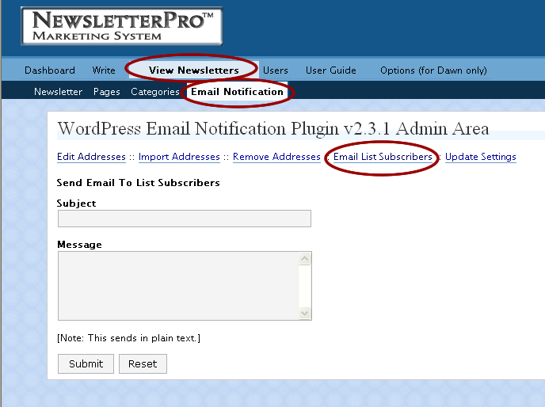

16 How do I send a test publish to myself (admin) or the Test group?

To do a test publish to either Admin or the Test group, check the appropriate box (see figure 11) and can hit either "save" or "save & continue editing" and the newsletter will be sent to the list that is checked... "Publish" will do a REAL publish to ALL subscribers.

Figure 11: Send a test copy of the newsletter:


